17 Key Frame Editor
On the Edit Page.
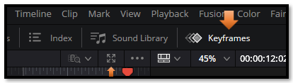
The little icon pointed out above will give you better access to your key frames. Just hit X in the upper left corner to close out and go back to viewing the smaller version of the panel.
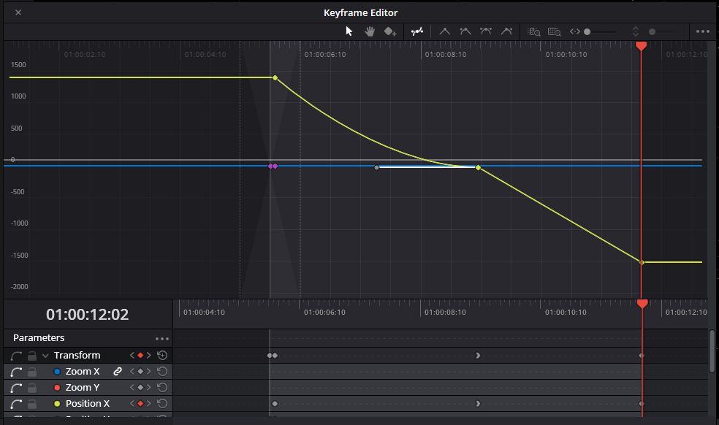

Inside of this larger panel, you can select the key frames and then go to the top and choose which type of easing you want for your frames.
